Fondazione Museo del computer
Via per Occhieppo, 29 13891 CAMBURZANO (BI)
Tel. 015 8853201 Fax 015 8853202
Mail info@museodelcomputer.org
Web www.museodelcomputer.org
CF 94064520037 PI 02314610037

OLIVETTI P6066 year 1978

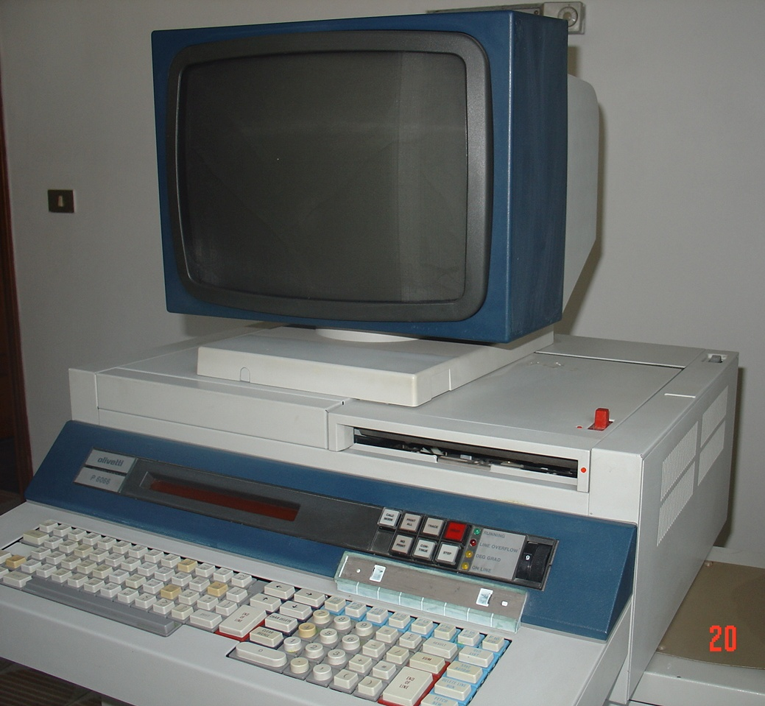  Olivetti P6066 is a personal computer for scientific purposes, equipped with an operating system with Olivetti's proprietary BASIC interpreter.  Identical in mechanics and bodywork to the P6060, it differs in color (milk white) and performance: essentially it is the subsequent improved version of the P6060, since it is possible to transform (upgrade) a P6060 into a P6066 simply by replacing some electronic boards resident in the logic package of the machine.  The main hardware difference lies in the increase in user memory from 16 KB to 48 KB, achieved by positioning the firmware (32 KB) in an alternative bank to that of the system and user software, and in the 30% increase in speed of the central unit achieved with the look ahead technique in the fetch of firmware instructions.  This series of machines, born with the predecessor P6060, was most likely the one that defined the definitive architecture of PCs, consisting of the presence of a ROM for loading the operating system resident on disks. | Start of sale 1978  End of sale 1984  CPU TTL based  ROM 32 KB to 64 KB  RAM 48 KB standard  Built-in keyboard Yes (alphanumeric)  Built-in display 32 character orange PDP alphanumeric. Optional external display 14" CRT monochrome  Built-in drives Thermal printer  Hard disk 1 or 2 8" 256 KB floppy disks. Optional external 10 MB hard disk.  Optional Ports: Serial RS232, IPSO proprietary, IEEE 488  Standard Peripherals PR series dot matrix printers, plotters, measuring instruments, punchers/tape readers, 14" monochrome monitor.  Standard OS Proprietary with BASIC interpreter  Other standard software Assembler  Weight 40 kg  Dimensions (H x W x D) 25 cm x 60 cm x 60 cm

