Fondazione Museo del computer
Via per Occhieppo, 29 13891 CAMBURZANO (BI)
Tel. 015 8853201 Fax 015 8853202
Mail info@museodelcomputer.org
Web www.museodelcomputer.org
CF 94064520037 PI 02314610037

OLIVETTI P6060 year 1976

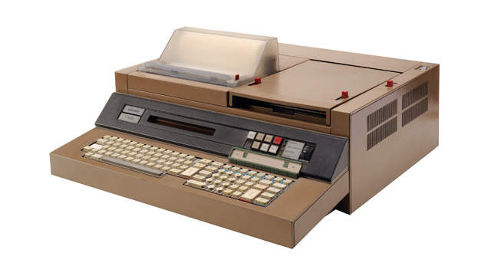  The P6060 computer, presented at the Hannover Fair in 1976 as a minicomputer dedicated to technical-scientific applications, is often used for complex management applications. It is an imposing-looking machine but complete with keyboard, thermal printer, plasma monitor, even if it displays only one line of text, a double lockable drive for 8” floppy disks. The computer, which does not yet use a microprocessor, has a CPU made with standard logic integrated circuits, a proprietary operating system and is programmable in Basic. | RAM memory: 48 kbyte  ROM memory: 32 kbyte  Mass storage:  2 floppy disks (8”) 250 KB Optional external hard disk 10 MB  Technology: Electronics  Keyboard:  Alphanumeric and function keys (97 keys) integrated in the machine  Printing device:  Serial thermal with graphic functions integrated in the machine  Printers, videos, plotters, measuring instruments, remote processor  Arithmetic logic unit:  Electronics with discrete components and integrated circuits  Display:  Alphanumeric plasma on a text line of 32 characters  Colors: Hazelnut  Production: since 1976  Dimensions: 60 x 65 x 21.5 (W x D x H)  Design: E. Sottsass and G. Sowden

