Fondazione Museo del computer
Via per Occhieppo, 29 13891 CAMBURZANO (BI)
Tel. 015 8853201 Fax 015 8853202
Mail info@museodelcomputer.org
Web www.museodelcomputer.org
CF 94064520037 PI 02314610037

OLIVETTI P6040 year 1977

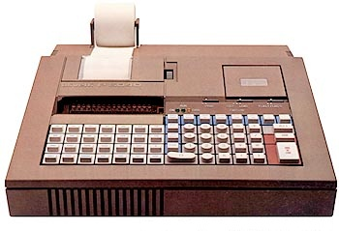  The P 6040 computer, the first Olivetti to use a microprocessor (Intel 8080), joins the more powerful P 6060 model, which has already been in production for a year. The field of application, as for the P 6060, remains technical-scientific, and therefore the reference “target” is the same as the products in the calculator line of the family born with the P 101.  The P 6040, advertised as a “personal minicomputer” is a machine complete with keyboard, dot matrix printer, LED display and 6.5 cm mini floppy disk. The display and printer can display/print only one line of 16 characters at a time.  The data storage system on the minidisk is unique: spiral like in old vinyl audio records, and not tracks and sectors like in all other types of floppy disks; with this system, the disk reading/writing, which must be done for the entire disk in a single pass, is sequential like that of magnetic tapes and therefore relatively slow.  The machine, thanks to the IPSO and RS232 interfaces, can easily be connected to scientific instruments, plotters, printers and readers of punched or magnetic tapes.  The computer is programmable in Mini BASIC, a subset of the Basic language composed of a few basic instructions and many mathematical functions.  Olivetti has marketed three versions of the machine: one to create and execute programs, another only to read them from the floppy disk and execute them, and finally a third in which the programs can only be written and saved on floppy disk.  The design of the machine, which weighs less than 8 kg, is by M. Bellini. | Microprocessor: Intel 8080  RAM memory: 2 KB expandable to 4 KB  ROM memory: 16 KB  Mass storage: 1 minidisk (6.5 cm) 3 KB  Power supply: Network  Keyboard: 62 keys  Printing device:  Serial/parallel needle, 16 characters per line  peripherals compatible with IPSO and RS 232 C standards  Display:  Alphanumeric LED on a 16-character text line  Body: Plastic material  Colors: Hazelnut  Production: since 1977  Dimensions: 36 x 40.6 x 11.6 cm (LxDxH)  Weight: 7.8 kg  Design: Mario Bellini

