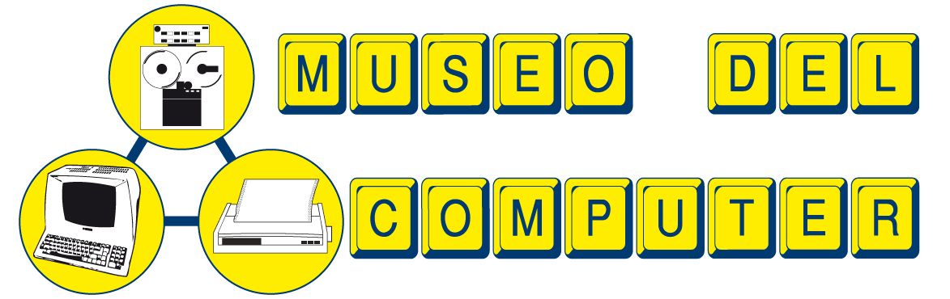 | 
WANG LABORATORIES SYSTEM 2200

50 years annyversary

Wang was an American computer company founded in 1951 by Dr. An Wang, an American engineer of Chinese origins.
The company reached his top in the 1980s then declined until Dr. Wang died in 1990 and finally went into bankruptcy in 1992.
The main company was acquired by Getronics, while the Italian branch became part of Olivetti.
The Wang System 2200 on display at this exhibition is a mini computer released to the market in 1973 (exactly 50 years ago).
It is based on TTL-wired CPU, with LSI ALU integrated circuit.
The ROM memory has a size of 16K and contains the Basic language interpreter.
The standard RAM memory size was 4K and could be expanded up to a maximum of 32K.
The CRT unit can display 16 lines of 64 characters each.
There is a custom interface to connect to a IBM typewriter to be used as a printer.
Data can be stored to a cassette recorder enclosed in the video terminal, or to floppy disk unit which could house three 8" disk drives, but this unit is quite heavy to move! :)
The selling price was around $7,000 and more than 60,000 units were sold.
In our Museum there are two of these systems, as well as a large number of spare parts and documentation, donated by the former Italian distributor of Wang.

 | COMPUTER MUSEUM FOUNDATION  Via per Occhieppo 29  13891 CAMBURZANO – BIELLA – ITALY  WWW.MUSEODELCOMPUTER.ORG  info@museodelcomputer.org  Phone +39 015 8853201

